DAY 3 – DATA MINING LAB EXERCISES

Q1. Apriori and FP-Growth
Given the first market-basket dataset shown in the table on page 1:
Perform the Apriori Algorithm and FP algorithm with:
- Support = 3
- Confidence = 50%

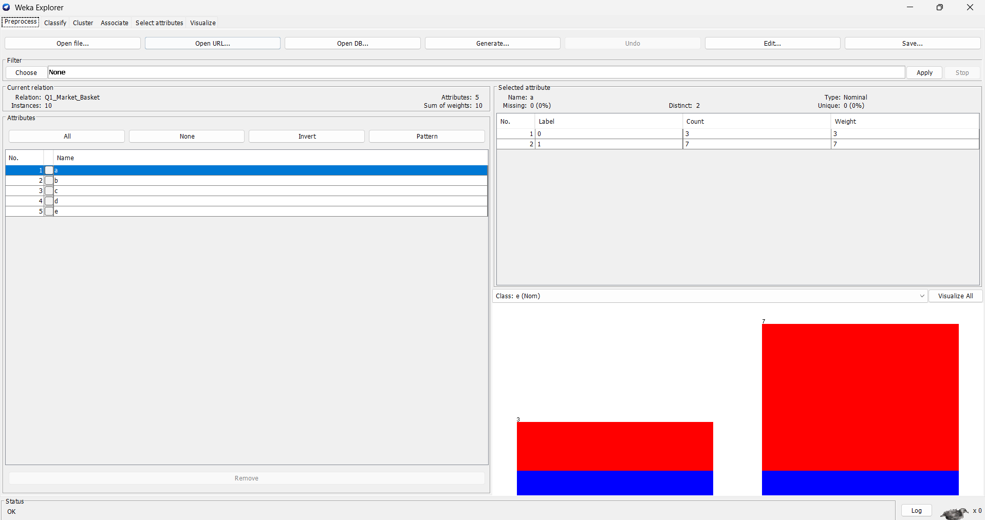

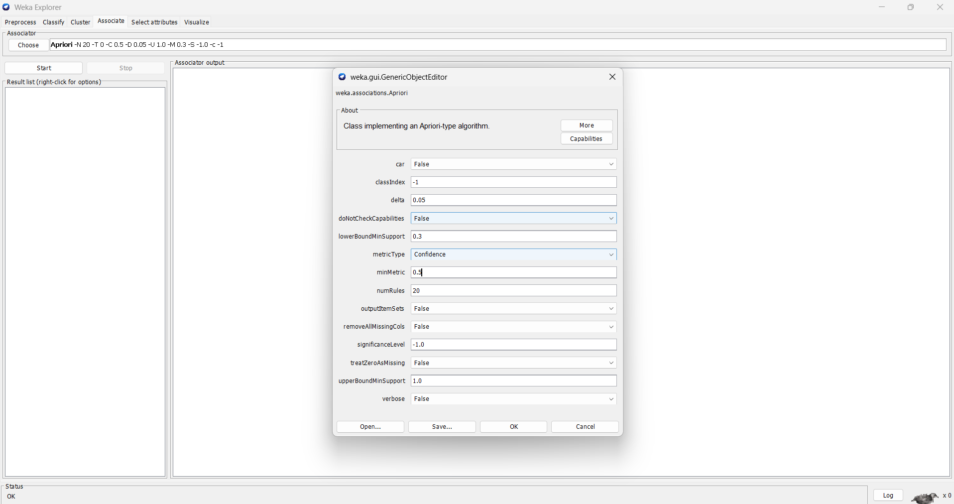

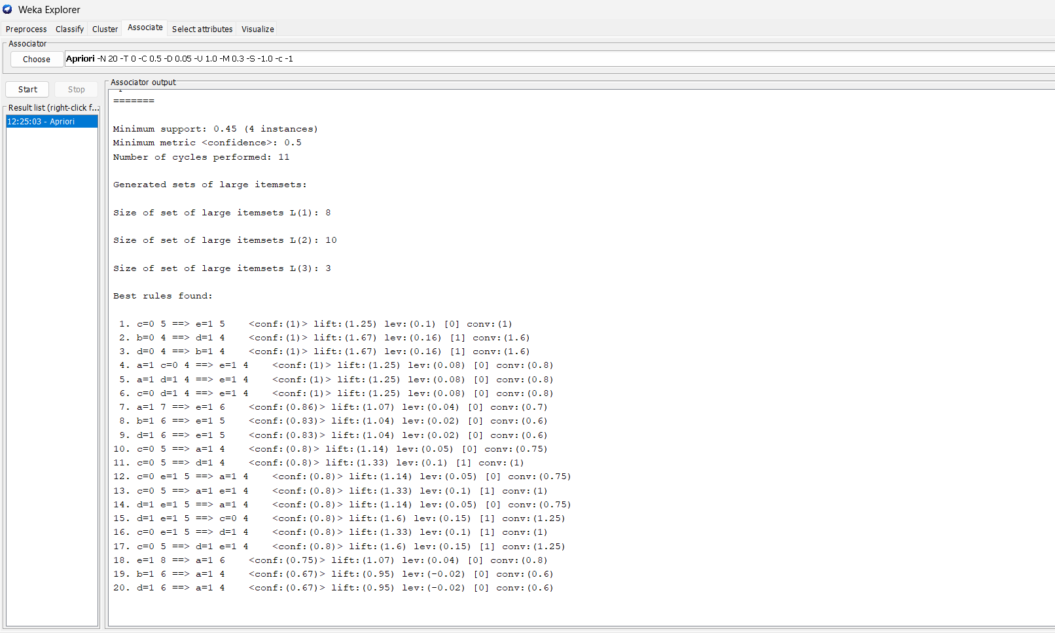

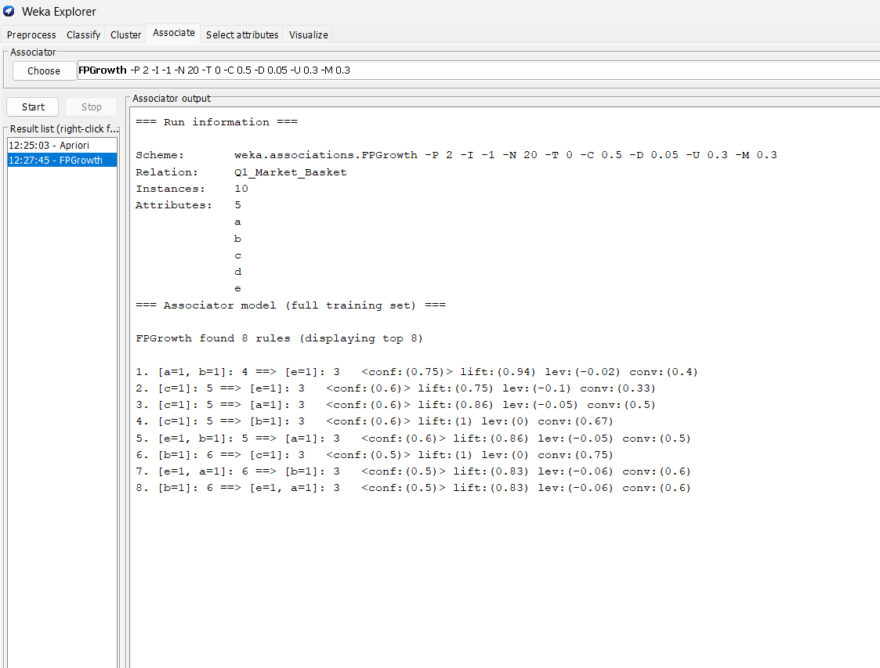

Q2. Association Rule Questions
For the second market-basket dataset shown on page 1:
(a) What is the maximum number of association rules that can be extracted from this data, including rules having zero support?
(b) What is the maximum size of frequent itemsets that can be extracted, assuming minsup > 0?

SOLN: (a) Maximum Number of Association Rules
The dataset contains 6 items:
Milk, Beer, Diapers, Bread, Butter, Cookies.
For each item, there are 3 possibilities:
- Item belongs to the left-hand side (LHS)
- Item belongs to the right-hand side (RHS)
- Item is not included in the rule
Therefore,
However, an association rule must have at least one item in LHS and at least one item in RHS.
Number of rules with an empty LHS:
Number of rules with an empty RHS:
The completely empty rule is counted twice, so add 1:
Answer: The maximum number of association rules that can be extracted is 602.

(b) Maximum Size of Frequent Itemsets
The condition given is:
Therefore, an itemset is considered frequent if it occurs in at least one transaction.
From the given dataset, the largest transaction contains 4 items:
Therefore, a frequent itemset can have a maximum of 4 items.
A 5-itemset or 6-itemset cannot occur because no transaction contains 5 or 6 items.
Answer: The maximum size of a frequent itemset is 4.

Q3. Bayes Classification + Decision Tree
Perform Bayes classification and Decision Tree classification using training and test data.

The dataset is the RID/age/income/student/credit-rating dataset shown below it.

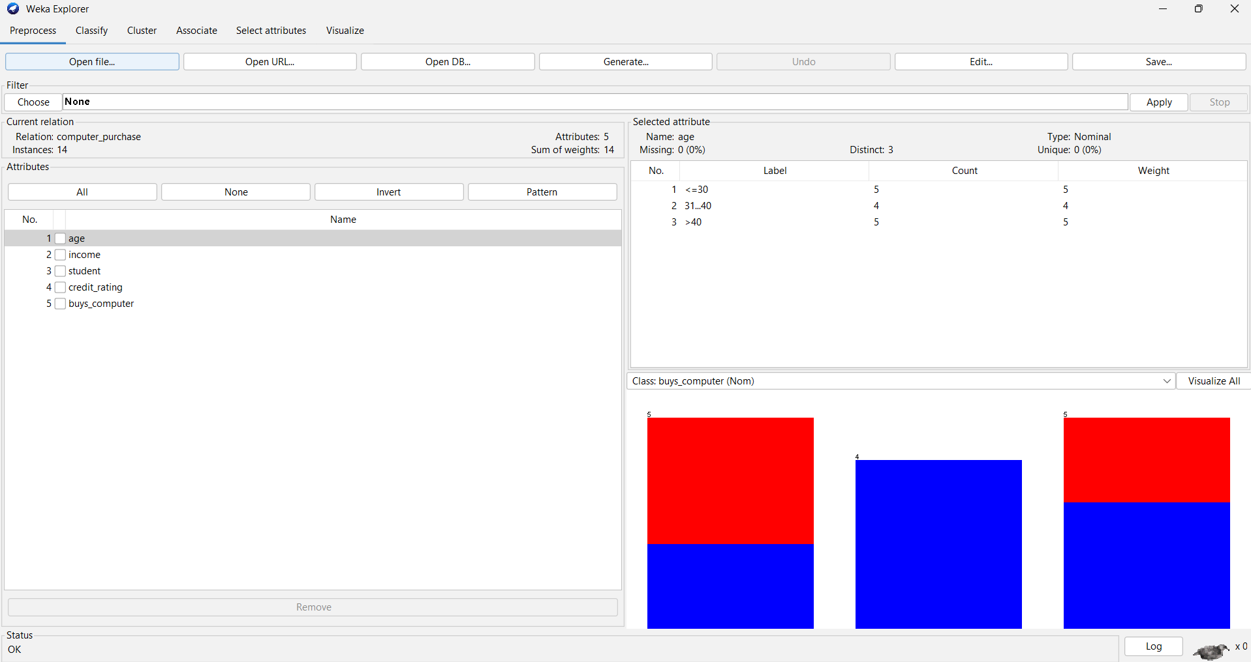

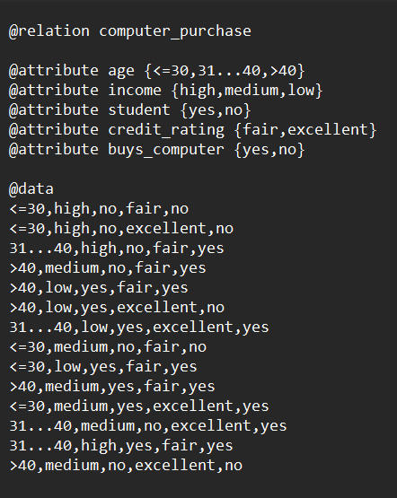
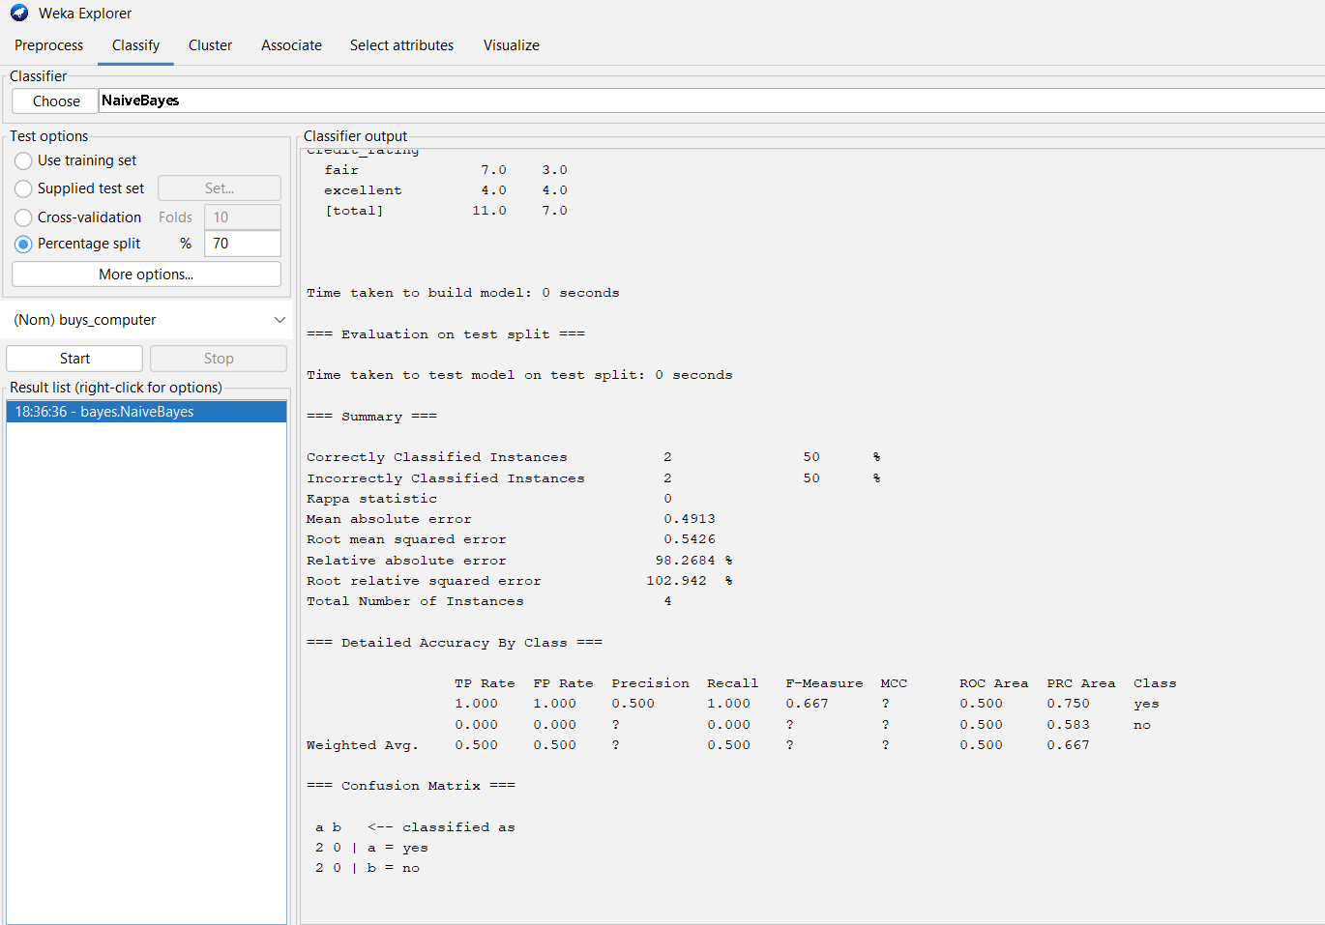

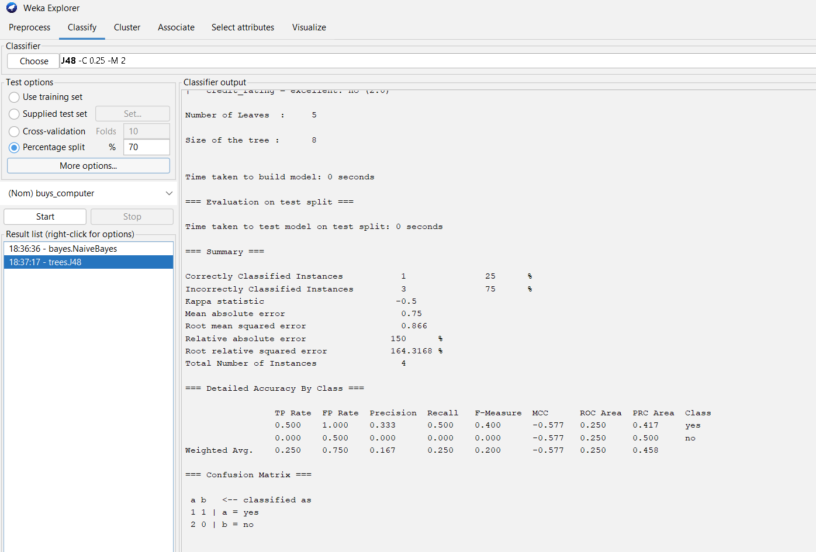

Q4. Diabetes Regression using WEKA
Analyze the dataset diabetes.csv to determine how the diabetes trend varies for different age groups, using:

Linear Regression

Multiple Regression

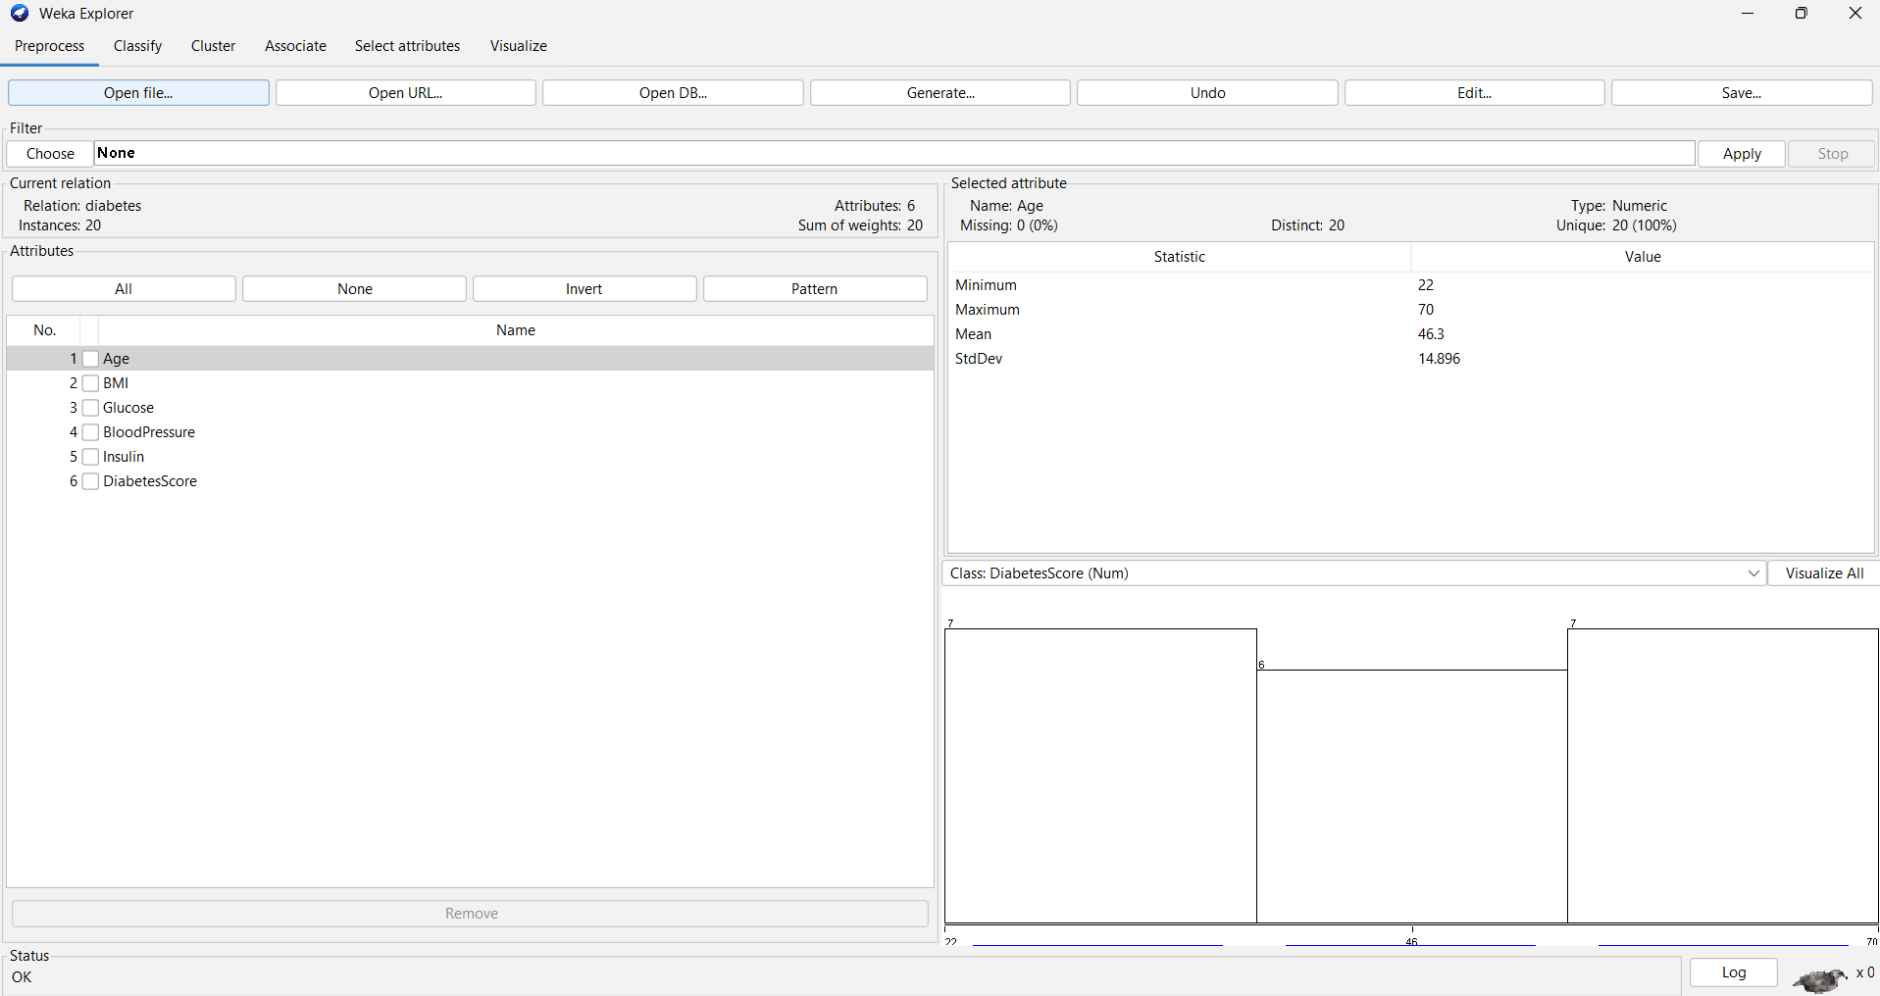

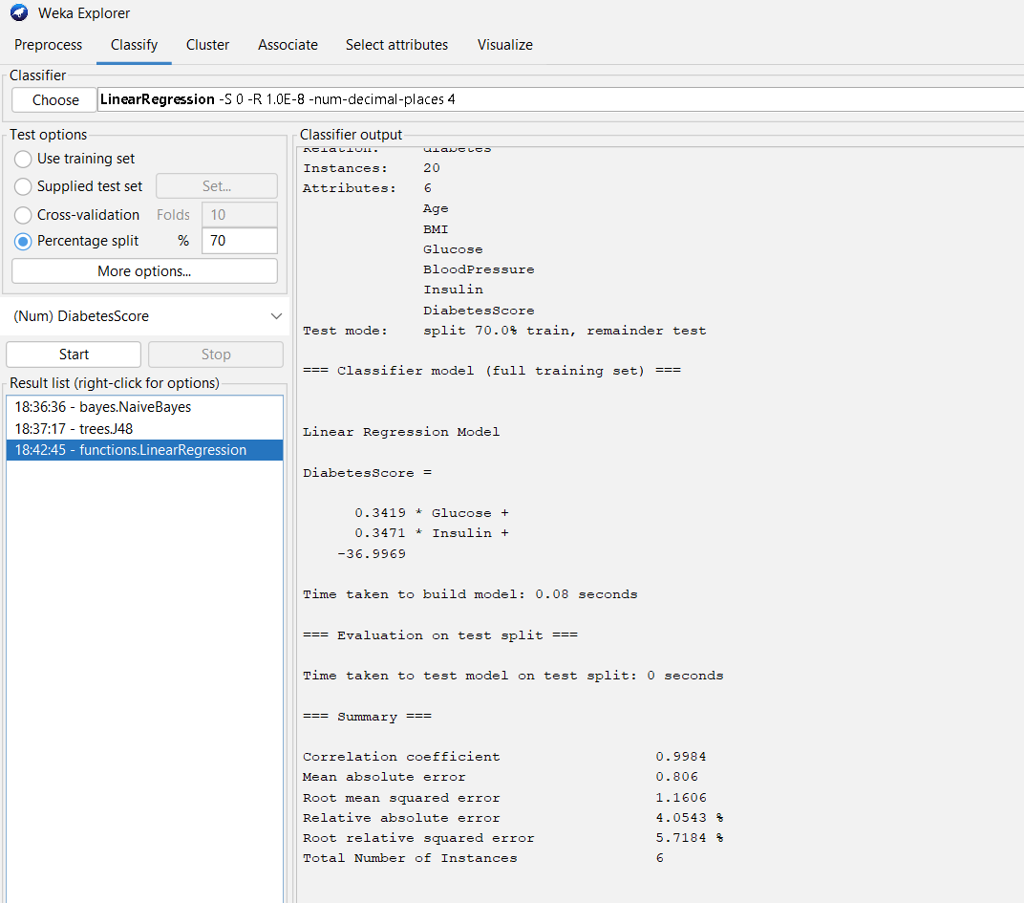

Q5. Apriori + FP-Growth — 5 Transactions
Given five transactions:

T1 = (M, O, N, K, E, Y)

T2 = (D, O, N, K, E, Y)

T3 = (M, A, K, E)

T4 = (M, U, C, K, Y)

T5 = (C, O, O, K, I, E)

Given:

Minimum support = 50% (2 transactions)

Minimum confidence = 80%

Tasks:

Find all frequent itemsets using Apriori

Draw the FP-Growth tree

SOLN

1. C1 → L1
Item | Support Count | Frequent?
M | 3 | Yes
O | 3 | Yes
N | 2 | Yes
K | 5 | Yes
E | 4 | Yes
Y | 3 | Yes
C | 2 | Yes
D | 1 | No
A | 1 | No
U | 1 | No
I | 1 | No
L1 = {M, O, N, K, E, Y, C}

2. C2 → L2
Frequent 2-itemsets:
Itemset | Support
MK | 2
ME | 2
MY | 2
ON | 2
OK | 3
OE | 3
OY | 2
NK | 2
NE | 2
NY | 2
KE | 4
KY | 3
KC | 2
So,
L2 = {MK, ME, MY, ON, OK, OE, OY, NK, NE, NY, KE, KY, KC}

3. C3 → L3
Frequent 3-itemsets:
Itemset | Support
MKE | 2
MKY | 2
ONK | 2
ONE | 2
OKE | 3
OKY | 2
OEY | 2
NKE | 2
NKY | 2
NEY | 2
KEY | 2
Therefore:
L3 = {MKE, MKY, ONK, ONE, OKE, OKY, OEY, NKE, NKY, NEY, KEY}

4. C4 → L4
The frequent 4-itemsets are:
Itemset | Support
ONKE | 2
ONKY | 2
ONEY | 2
NKEY | 2
OKEY | 2
So:
L4 = {ONKE, ONKY, ONEY, NKEY, OKEY}
No frequent 5-itemset exists.

Association Rules
Minimum confidence = 80%
Some accepted rules include:
- M → K = 2/3 = 66.67% ❌
- M → E = 2/3 = 66.67% ❌
- N → K = 2/2 = 100% ✅
- N → E = 2/2 = 100% ✅
- O → K = 3/3 = 100% ✅
- O → E = 3/3 = 100% ✅
- K → E = 4/5 = 80% ✅
- K → O = 3/5 = 60% ❌
- Y → K = 3/3 = 100% ✅
- Y → N = 2/3 = 66.67% ❌

FP-Growth Tree
For FP-Growth, arrange items according to decreasing support:
K(5) → E(4) → M(3) → O(3) → Y(3) → N(2) → C(2)
Then insert the transactions according to this order and construct the FP-tree.

Result
The Apriori algorithm produced frequent itemsets up to size 4. The frequent itemsets were obtained using minimum support of 50% (2 transactions), and association rules satisfying the minimum confidence of 80% were identified. The FP-Growth tree is constructed using the items arranged in descending order of support.

Q6. Decision Tree Classification using WEKA
Prediction of Categorical Data using Decision Tree Algorithm through WEKA, using any dataset.

The PDF specifically asks for:

a) Tree

b) Preprocess

c) Logistic

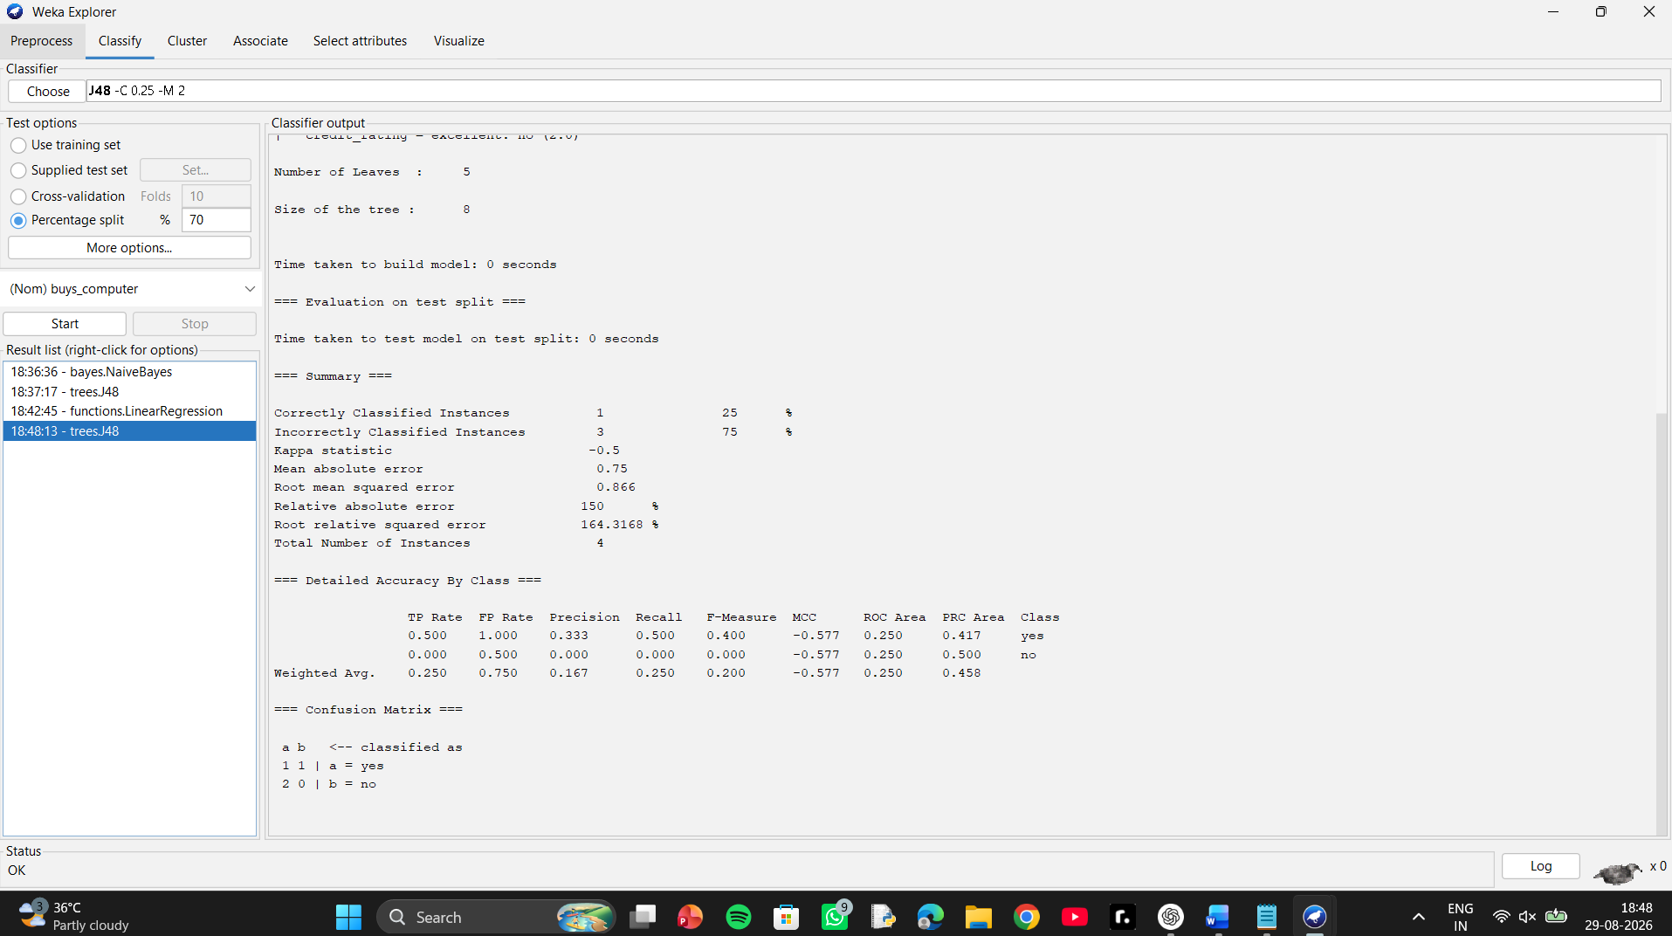

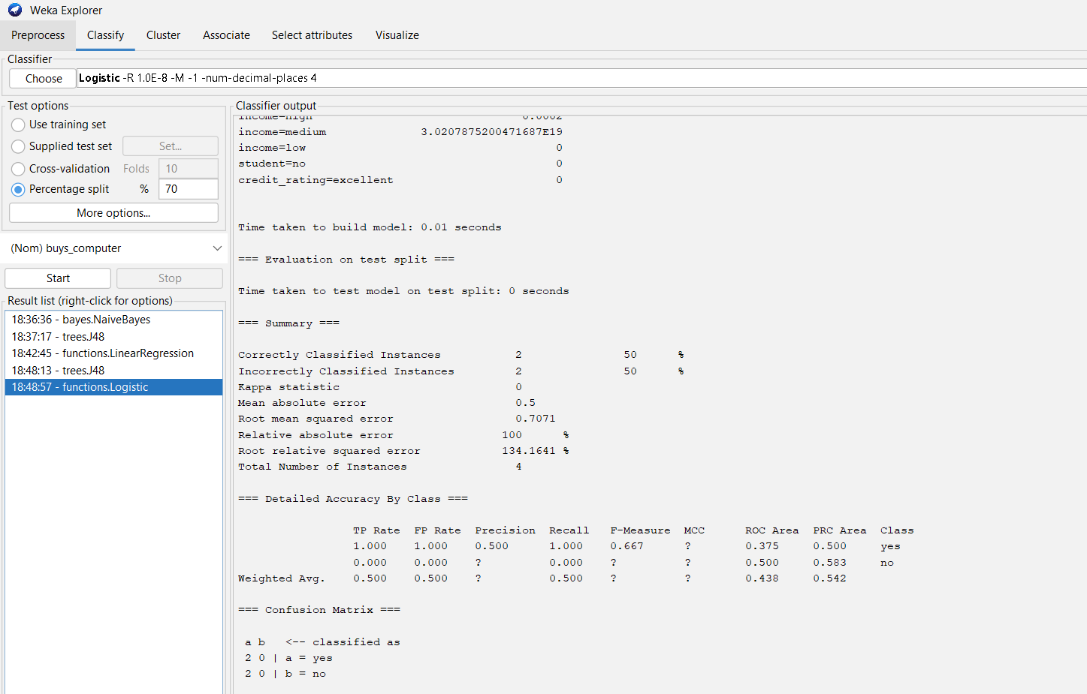

Q7. ARFF + Apriori + FP-Growth
Create the given dataset in ARFF format:

Transaction Items
T1 Hot Dogs, Buns, Ketchup
T2 Hot Dogs, Buns
T3 Hot Dogs, Coke, Chips
T4 Chips, Coke
T5 Chips, Ketchup
T6 Hot Dogs, Coke, Chips

Then:

(a) Find the frequent itemsets and generate association rules.

Given:

Minimum support = 33.33%

Minimum confidence = 60%

(b) List the various rules generated by Apriori and FP-Tree algorithms, and mention whether each rule is accepted or rejected.

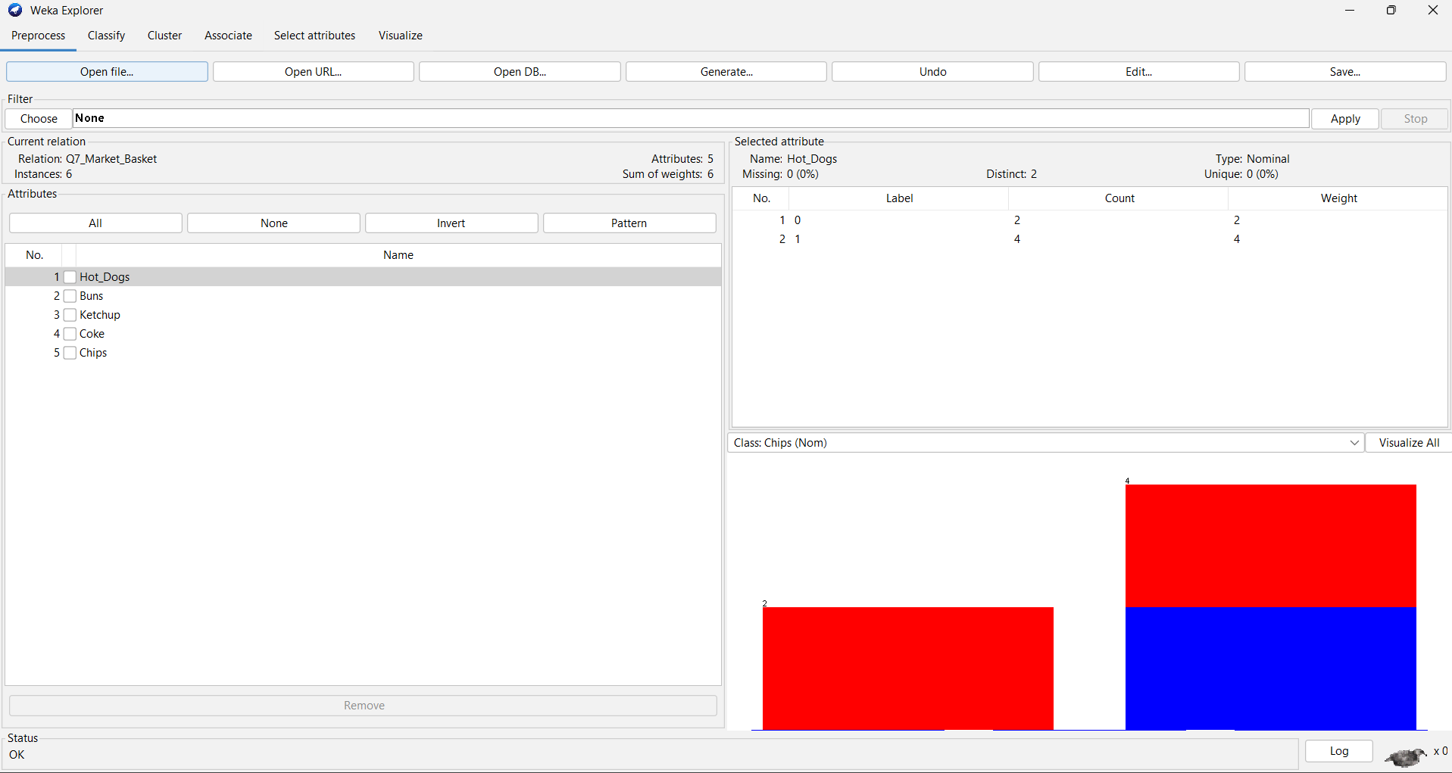

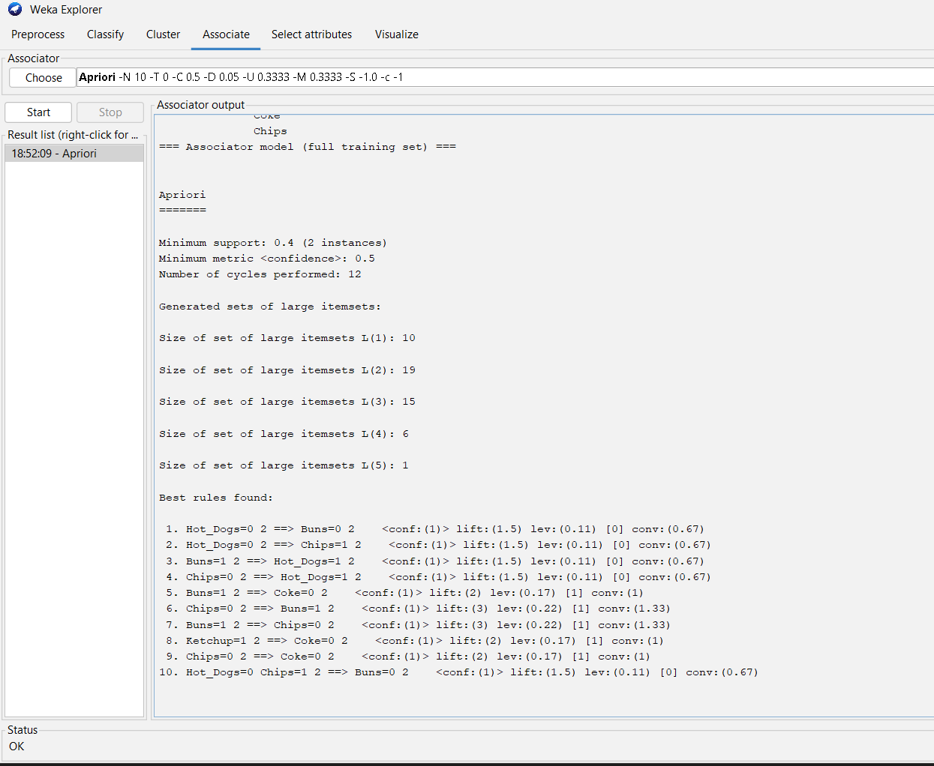

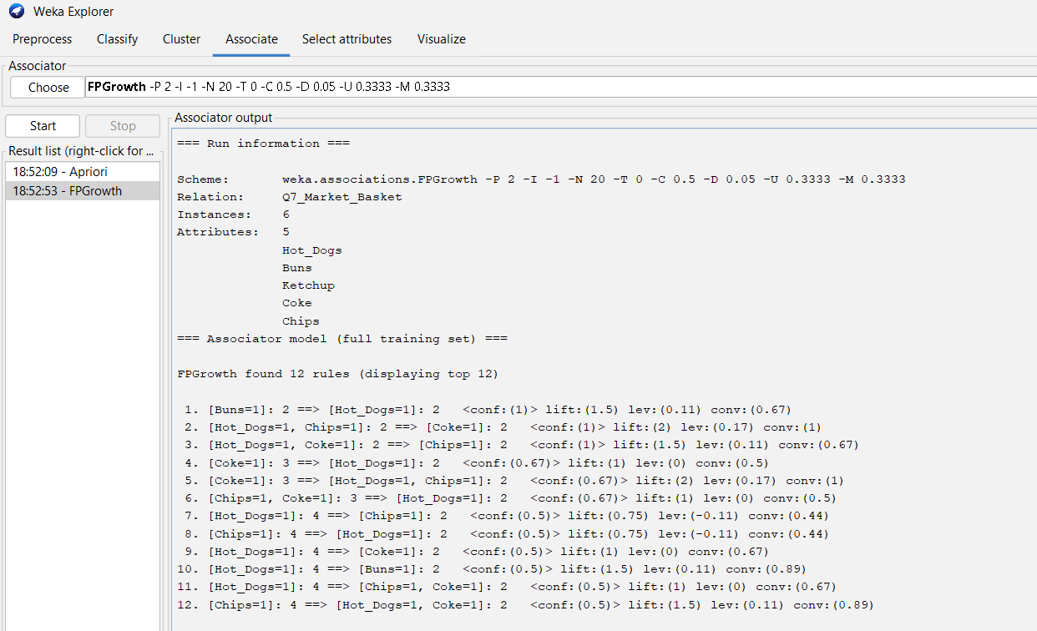

Q8. Rule-Based vs Decision Tree Classification
Perform prediction of categorical data using:

Rule-based classification

Decision Tree classification

Then:

Compare the accuracy of both algorithms.

Plot a graph comparing their accuracy.

